Industry Mentor Page Review

Industry Mentor Page Review  Date: 2/9/2021 Page 1 of 3 | Reviewing team  Team 18 – Smooth Operators | Reviewed Team  Team 15 – Mind Ink Bots
Secret URL | Link - https://bit.ly/3yBOyjq  The bit.ly link could have the name of the website or related to the purpose the website is trying to achieve or even anything related to the target audience which would give an idea what the link is about at a glance and also give a personalized touch.
Type of Device used for this review | Windows 10 & MacOS (Big Sur) Laptops
Browser used for this review | Google Chrome & Safari
Audience
The page starts off with a text “IM – TE15- Mind Ink Bots – Trust N Drive” which we think Team 15 can improve. The text doesn’t tell out right who the audience of the page is. It is easy for us (Students and Studio Mentors) to understand the abbreviation ‘IM’ but it may not be so familiar to the Industry Mentor.
The ‘Mind Inks Bots’ and ‘Trust N Drive’ could be labelled as Team name and Website name to make it more understandable.
Our Suggestion: The Page title of the Mahara Industry mentor page can be something like “Industry Mentor Page for Team Mind Ink Bots (TE15)” and then set a website name and logo Place holder below as a non-retractable.
Visual design
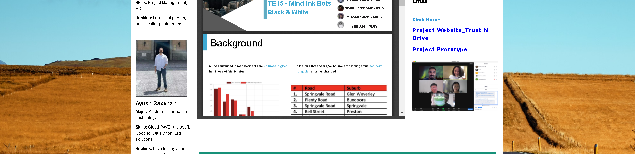
This page uses a scenic photo of a highway as a background, with the main color scheme of yellow and blue. We think the image was chosen appropriately to improve the aesthetics of the site and the road photo fits the theme of the team 15 project as well. However, we were concerned that the large area of yellow in the background image would be uncomfortable for people with yellow-green colorblindness, which will need to be further verified by team 15.
The visual design of the Mahara page is decent and appealing. The page has the Team Logo on the right side looks modern and sleek. On the left side of the page, you can see pictures and description of the team, which is a nice idea.
In Visual design team 15 needs to make slight changes and review the color of background, otherwise, good job!
Our Suggestion:
- Regarding the Yellow-green colorblindness, Team 15 can deliberate within themselves and decide based on their personal preference whether they want to change it or keep it.
- In terms of the teams profile pictures on the left side, to represent a unified front, the pictures can be cropped to a standard size for each team member. If possible, team members could upload a more professional picture with a plain or white background, since their Industry mentor are also potential sponsors.

Text-based design
The overall text design and choice of words on the page is good, all text has sharp contrast with the background, due to which we can clearly see the required information. We proof-read the text on the page and found that it was appropriately punctuated and no grammatical errors.
However, we think the font in the Project Description section is a bit small, which makes it hard to read.
All headings are differentiated with larger fonts, and important headings are highlighted in green.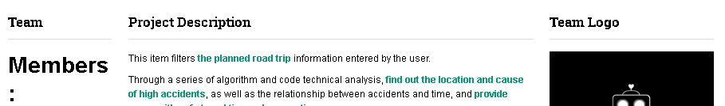
In addition to this, we notice that left column heading “Members” stands out more than other headings, we are unsure if this is the intention, if you want IM to view your members column first or to know about the project.
In the Text-based design section we think team 15 has done a respectable job.
Our Suggestion:
- Increasing the font size on the non-retractable Project description text may improve readability.
- We suggest categorizing all headings to similar font and matching sizes. For example, Heading-1 (size 12, Most Important); Heading-2 (size 11, Medicore important), Heading-3 (size 10, low importance). Based on the importance of that section and eyeball it needs, it can be sized accordingly.
Audio/Visual Features
Two videos are provided in the web page, Iteration 1_UI Model and Iteration 1_Usability testing video.
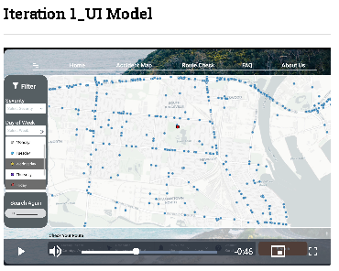
The first videos, Iteration 1_UI Model, has no sound when played normally by our group. This needs to be verified by TEAM 15. If this video does have no sound, we think it would be more appropriate to add an explanatory background sound to the video.
The second video, Iteration 1_Usability, plays fine, and the dialogue in the video is very clear. The clarity of the video also meets the requirements. Well done.
Our Suggestion: Iteration1_UI Model video could include a talk through, a narrator explaining the actions he/she is doing to make it more comprehendible.

Personality of the site
The overall design of the website is very reasonable and shows all the useful information. The personality of the website matches the theme of their project. Their project is based on high level algorithms and code analysis which is reflected in their team logo and look and feel of the Industry mentor page.
No Suggestion.
Content (including the appropriateness of the writing style of any text)
The text on the site is short and clear, and does not take a lot of time to read and access the information.
Important text content is highlighted in green and blue, which makes it easier for the reader to focus on the important points/take-aways from that text.
All statements are made in declarative sentences, which tell the viewer the fastest possible information. Team 15 did a decent job in this section.
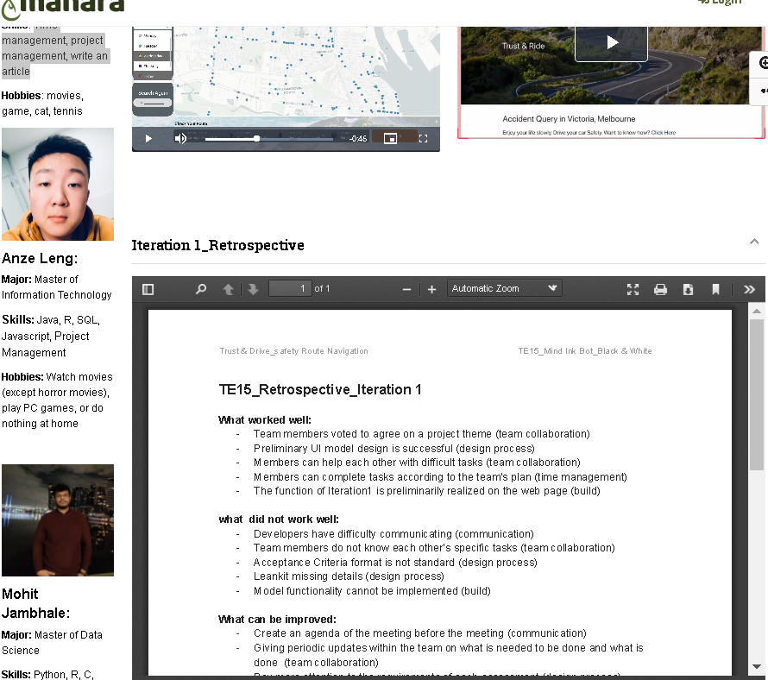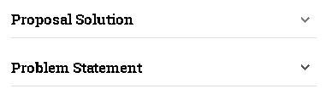
Our Suggestion:
- Iteration 1_Retrospective is not something the industry mentor would be interested in looking at. Thinking of the industry mentor as your client or potential sponsor helps you to understand the content which is appropriate to go on their page. We feel that sharing reflection of team dynamics with industry mentor would be unnecessary.
- The Problem Statement and High-Level solution (Proposal Solution on Team 15’s Mahara Page) could be on the top of the page just below the project description as a non-retractable to give an instant overview of the Project.

Any technical aspects the team should consider
No suggestion.
Navigation

Since the web page is only one page, there is no navigation bar designed. However, the overall layout of the page is very well organized, with the newest and most important content and areas placed at the top of the page. Important milestones such as Iteration 2, Iteration 1 and Documentation are separated from the rest of the site by green headings, so that we can find the information we need quickly. Within the three sections, there are many subheadings to display the respective documents and content.
The design is very logical, and we found it easy to navigate through the site.

Overall, Team has done a decent job in this section.

No Suggestion.

Anything else, you can think of to improve the site?

Our Suggestion:
- Since we are in Agile environment and software artefacts are constantly changing, they can be put as links to google drive governance folder, so they are always up to date on Mahara. Whereas documents like feedback reports, design and analysis reports can be uploaded as PDF documents in readable format.
- The team can add their Team name and Logo as a Placeholder as well.
- Enlarging some of the fonts could further improve the readability of the site. Maybe prioritizing the paragraphs and or headings that are more important, to be larger than others.
- We felt some areas seemed moderately mismatched. We noticed that the links section uses blight blue and dark blue, while the overall site uses a brown background, and some text and headings are in green. We recommend choosing a color theme, maybe similar to your original theme or matching to website and matching your IM page to that, so that IM pages gives the sort of impression that it’s a part of the project.

