Monash University
Sir Zelman Cowen School of Music

Basic instructions for creating an e-Portfolio with Mahara v16.04
For undergraduate assessment tasks

Mahara is an open-source, online tool for building professional electronic portfolios, also known as ePortfolios. Mahara allows you to create and select individual folios or ‘Pages’ from your bank of materials, which can be used for a variety of functions in relation to your studies and/or professional practice.
For instructions or troubleshooting beyond what is provided below, Mahara provides a detailed User Manual at http://manual.mahara.org/en/16.04/. If you are having issues that are not immediately resolvable through these resources, Monash eSolutions may be able to assist you: http://monash.edu/esolutions/.
*****
Contents
1. Accessing Mahara and setting up a profile 2
1.1 Creating a private profile 3
1.2 Creating a public profile 6
1.2.1 Adding Text 7
1.2.2 Adding an Image 8
1.2.3 Adding an Audio or Video File 10
1.2.4 Adding External media 11
1.2.5 Adding Profile information 13
2. Using Mahara 15
2.1 Collecting files 15
2.2 Creating a journal 15
2.3 Creating a “page” 19
3. Using your ePortfolio 22
3.1 Uploading your ePortfolio to Moodle for Assessment 22
3.2 Sharing your ePortfolio with potential employees 22

1. Accessing Mahara and setting up a profile
The Mahara platform is hosted by Monash University Faculty of Arts and is automatically linked to the Moodle pages for those units that require it. You will find the link on your unit’s Moodle home page.

When you click on the Mahara link, you will be taken outside of Moodle to your Mahara “Dashboard”, as shown below.

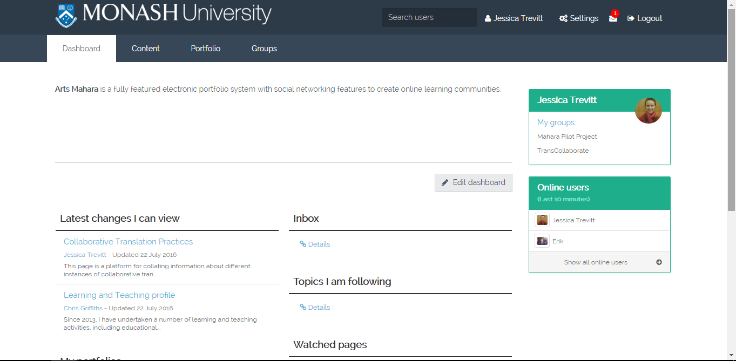

This page will greet you whenever you log on to Mahara through Moodle. It allows you to navigate to your profile, your collection of files, the various pages of your e-Portfolio and any social connections you make on your account. From here you can start building your profile and e-Portfolio.
*****

1.1 Creating a PRIVATE profile
Some information for your Mahara profile, such as your name and student ID number, has been automatically populated by Moodle. You can access this information by hovering over the “Content” tab and clicking on “Profile”.

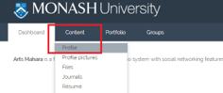

This will take you to your private Mahara profile, which is NOT the same as your public Mahara profile (see 1.2 below). The information you fill in here will NOT be made available to anyone searching for you on Mahara, unless you link it with your public profile.

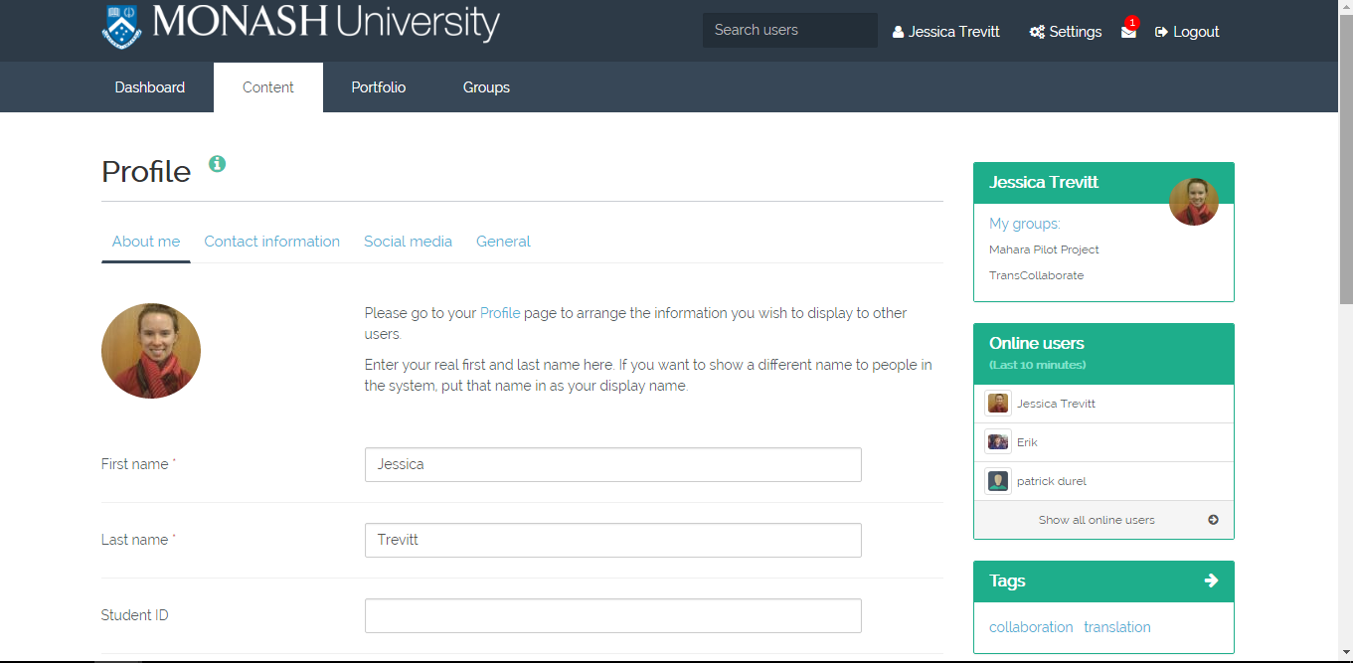

Below “Student ID” you will see you have the option of choosing a “Display name” if you would like your professional e-Portfolio to present you under something other than your “Monash” name.

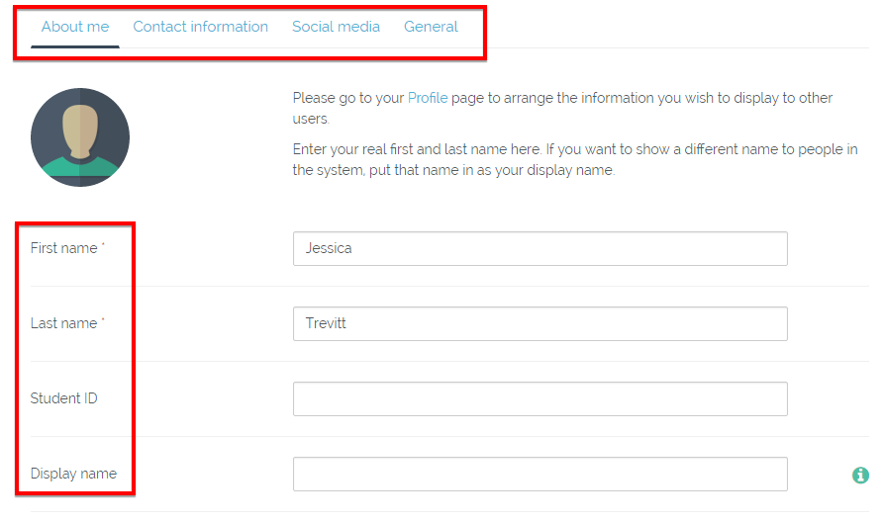

1.1.2 Change profile picture
You can change your profile picture by clicking on the “avatar” image.

On the page that appears, scroll to the bottom to upload an image from your computer. This image will appear next to your public display name, on your public profile and on your e-Portfolio. We recommend you choose a “professional” type photo, as you may wish to forward your e-Portfolio contents to potential clients or employers.

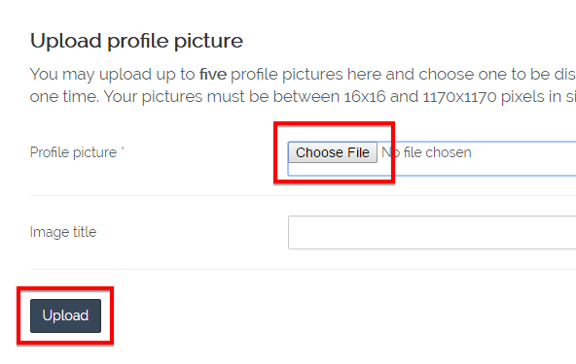

Then return to the top to select that image as your “Default”.

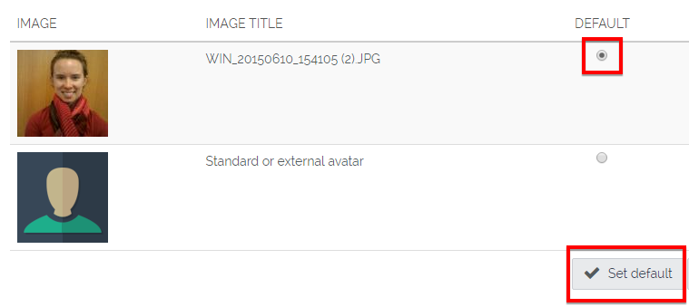

A green bar will appear at the top of the page with a message confirming your new default picture. To return to your profile, hover over the “Content” drop-down menu just above this bar and select “Profile”.

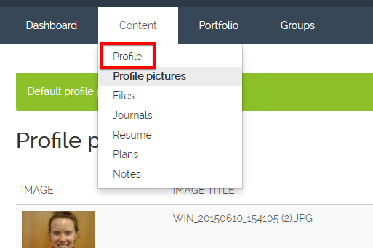

When you have completed your profile, click “Save profile” at the bottom of the page.
*****

1.2 Creating a PUBLIC profile
Your public profile page works similarly to a social media profile page: it is accessible to other users of Mahara who belong to your network of contacts. However, it differs from many social media sites as you are able to control the type of content that appears on the page.

You can set up your public profile by clicking on the link provided at the top of the “About me” section.

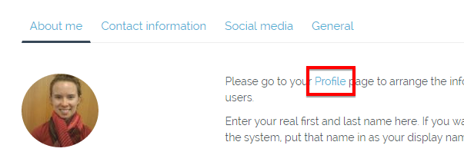

On your public profile page, click on “Edit content”.

A list of options for profile page content appears on the left-hand side.

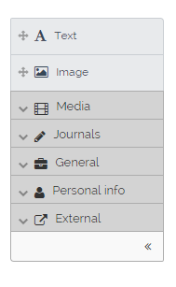

You can drag and drop any of these into the columns and rows of which your profile page is made up, and at any point during the editing process you can drag them to new positons on the page. These are known as “Blocks” of content.

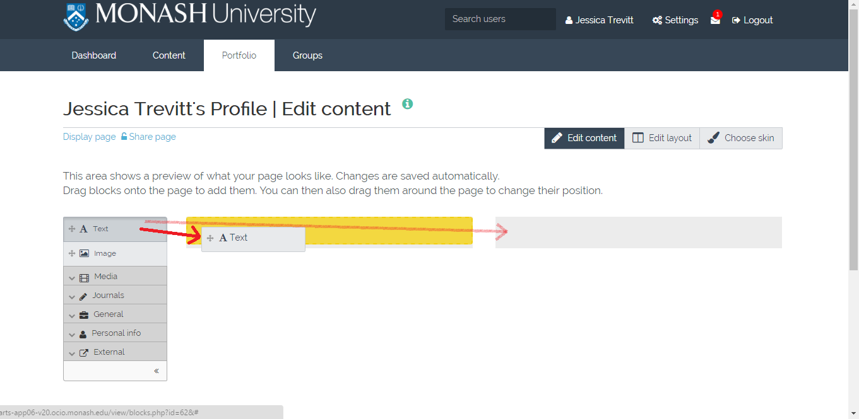

Every time you drag and drop a block of content into your profile, a ‘Configure’ box will appear to allow you to edit content for that section.

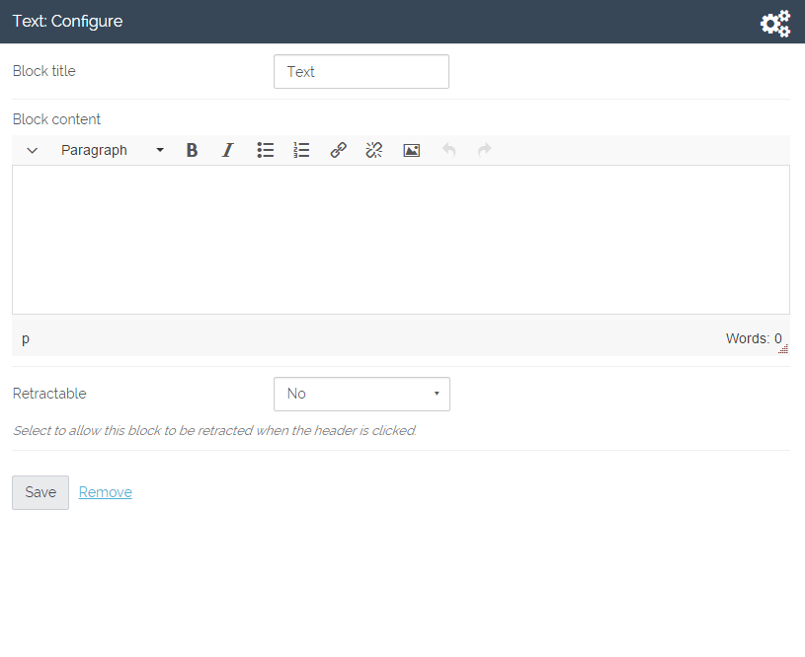

The options you have here will differ depending on the type of content you are editing.

*****

1.2.1 Adding Text
When you add text to your profile, in the “Text: Configure” box you will just need to add a “Block title”, write your content and click “Save”. If you don’t want a heading for this block of content, leave the “Block title” box empty. You may like to use this option to add a self-introduction to your profile page. If you completed this part of your profile earlier, however, you will be able to import that into your profile page, as discussed further below.

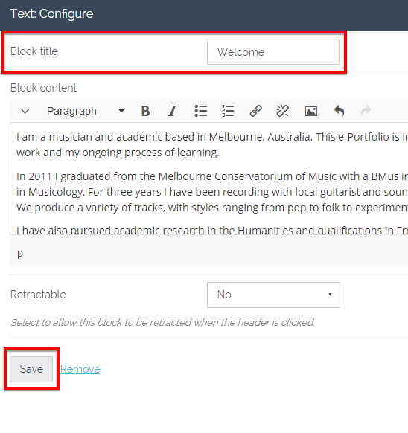

Your text will now appear on your profile page. The Block title will appear in a black bar, but this is only the case for the “Edit” view; the public display of your profile page will present Block titles with a simple underline.

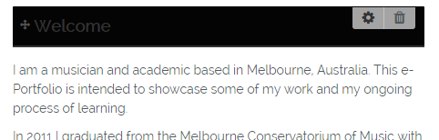

*****

1.2.2 Adding an Image
When you add an image to your profile, in addition to adding a Block title in the “Image: Configure” box you will need to expand the box by clicking on the downward arrow.

You will then be given the option to upload a photo from your computer. Anything you upload to Mahara will automatically be added to your Mahara file bank, making it accessible as content on any other Mahara “page” you might develop.
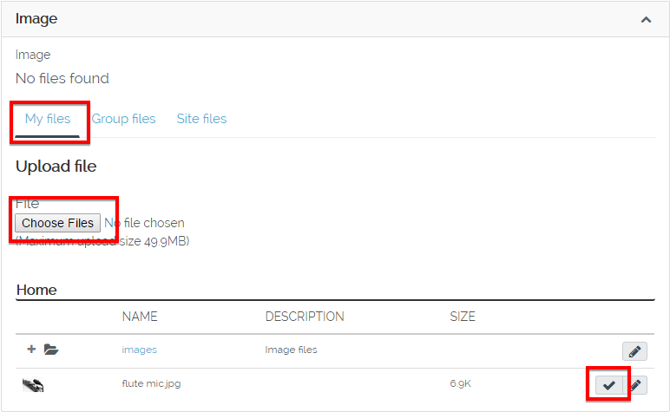

You can then add your description and click “Save changes”.

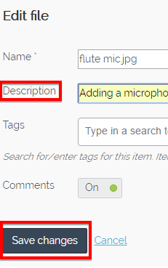

Finally, click “Save” at the bottom of the “Image Configure” box and the image and its description will then appear on your profile page alongside the text you added earlier.

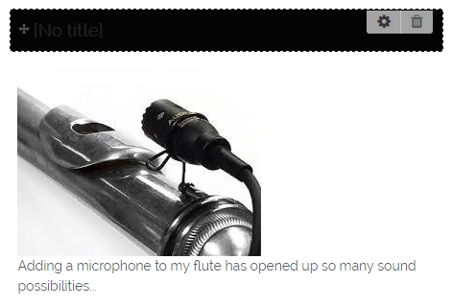

1.2.3 Adding an Audio or Video File
If you would like to add an audio or video file, click on the “Media” tab in the left-hand menu, select “Embedded Media” and drag it to the position you would like it on your page.

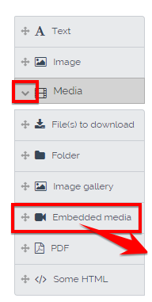

In the “Embedded Media: Configure” box, add a Block title and click on the downward arrow to expand the box.

In the expanded box you can either upload a file from your computer or select it from amongst those you have already saved in your Mahara file bank.

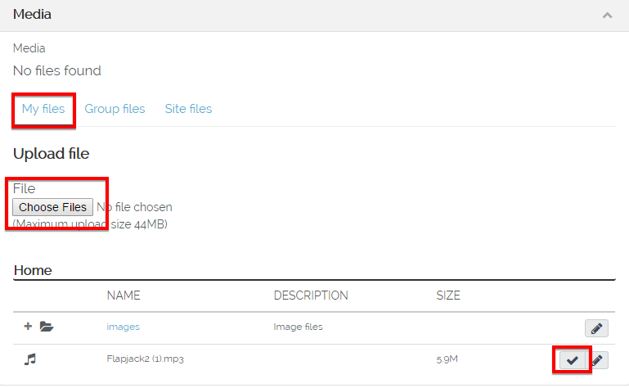

Once you have uploaded or selected your file, the expanded box will retract and you can click “Save”. Your media will now appear on your Profile page, and you will be able to click “Play” immediately to check it is working.

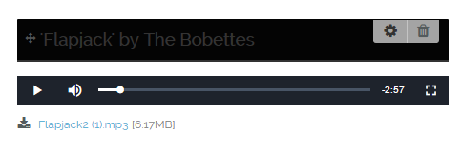

1.2.4 Adding External media
If the media you would like to add is available online rather than saved on your computer, you can click on the “External” option in the left-hand menu, select the appropriate platform and drag it to the position you would like it on the page.

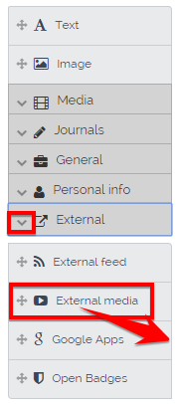

In the “External media: Configure” box, you will need to add a Block title and paste in the URL of the YouTube clip embed code.

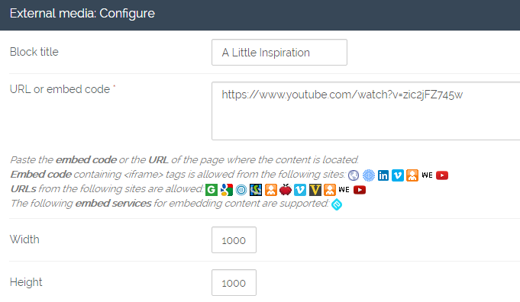

Once you click “Save”, the video will appear on your profile page and you can click “Play” immediately to check that it works. If the size you specified doesn’t quite work, you can click on the “Edit” icon in the top right-hand corner of the video.

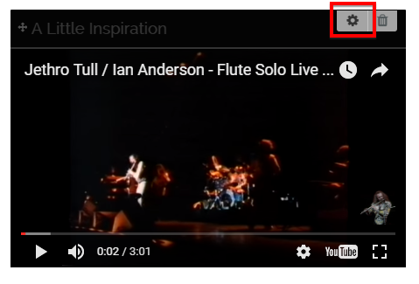

1.2.5 Adding Profile information
You also have the option of adding to your profile page any or all of the information you added to your profile earlier, including your name, profile picture, social media accounts, etc. You can do this by clicking on the “Personal Information” tab in the left-hand menu, selecting “Profile Information” and dragging it to the position you would like it on the page.

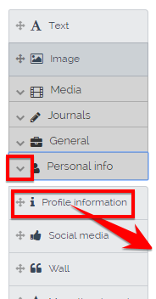

In the “Personal information: Configure” box, you will be asked to add a Block title and to select the aspects of your profile information you would like to insert.

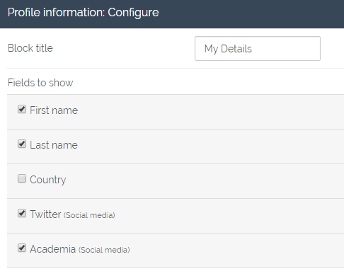

You will then need to specify whether or not you would like to display your profile picture in miniature next to this information, and whether you would like to make your email address public.

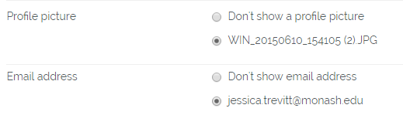

Click on “Save” and your chosen profile information will appear on your profile page.

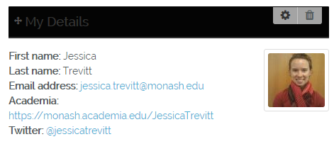

These are the basic options for your profile page, but there are many more in the left-hand menu, so you can explore other options. You will find that you can add Word/PDF/PPT files, folders of documents, image galleries, forum posts, journal entries, etc.

As you keep adding content to your profile, you will work out the best way to present it all visually. To help you explore this, the arrangement of columns and rows can be adjusted by clicking on “Edit layout” on the right-hand side, and the colour palette can be adjusted by clicking on “Choose skin”.

Once you are happy (for now!) with your Mahara profile page, click on “Display page” at the top left-hand corner and you will be taken to the public view of your profile.

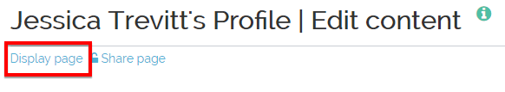

If there is anything you would like to change, click on “Edit this page” in the top right-hand corner.

You have now completed your Mahara set-up, and you are ready to move on to creating your e-Portfolio.
*****

2. Using Mahara

2.1 Collecting files
To begin adding files to Mahara, hover over the “Content” tab and click on “Files”.

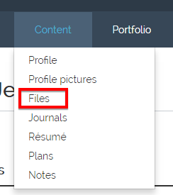

To add any type of file saved on your computer, click on “Choose files” to upload them, or drag and drop them into the grey box.

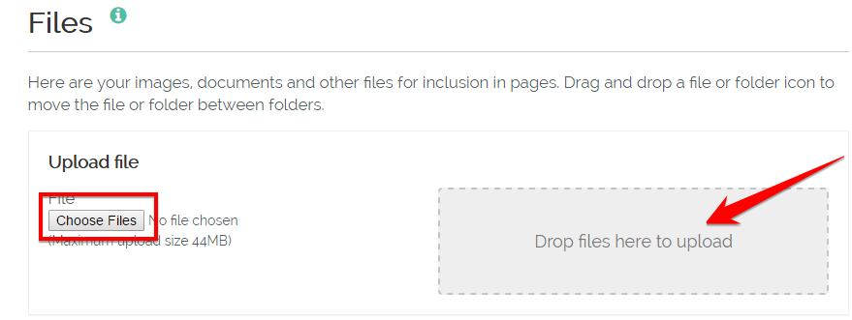

They will appear in the list beneath, and you can sort them into folders if you wish. Then you will have the option of adding entire folders of documents or galleries of images to any of your pages.

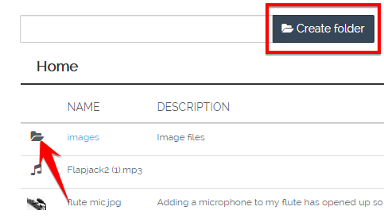

2.2 Creating a journal

Note for School of Music Students
For assessment purposes, you may be required to add a series of timestamped journal entries over a certain length of time. The date and time of your entry will be automatically recorded by Mahara. See your assessments for more information.

To start creating a journal, hover over the “Content” tab and click on “Journals”.

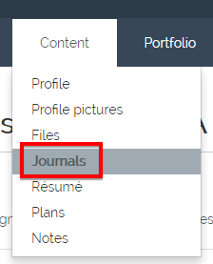

This will take you to the default journal created when your account was first set up. If you would like to make more than one journal, follow the link to the “Account settings”.

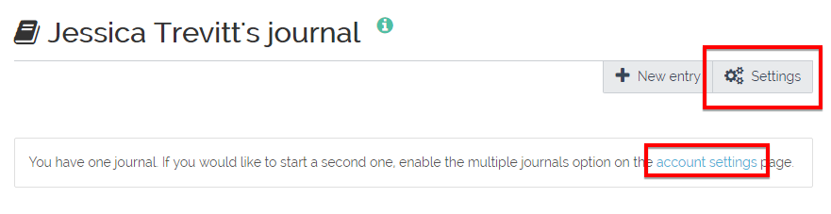

If you click on “Settings” you can change the title of this journal and add a description. Don’t forget to click “Save Settings” at the bottom of the page. When this is done you can write your first journal entry by clicking on “New Entry”.

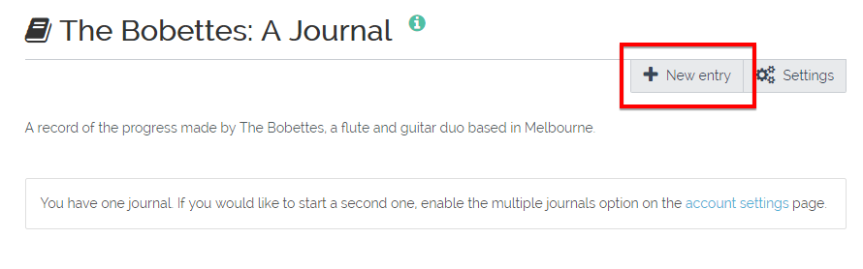

You can upload files to accompany your journal entries. Toward the bottom of the page, click on “Add file”. You can upload a file or select a file already uploaded to Mahara, as it will appear automatically on the list. Once you have selected the file you want, click the “X” in the top right-hand corner of the box.
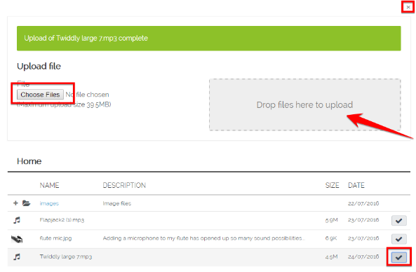

When you are back on your journal entry, you should see the uploaded file, with the option to “Remove” it if you wish.
You are also given the option of leaving your entry as a draft and returning to it later, by clicking on the “No” so it becomes a “Yes”. If you don’t do this, the entry will be published, but it won’t be visible your public Mahara account until you add a journal feed to any one of your pages, including your profile page. This will be addressed further below.

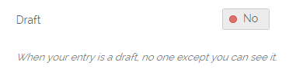

Once you are happy with your entry, click “Save entry” down the bottom of the page.
*****

2.3 Other Content Options
In addition to adding files and a journal, there are other options available to you under the “Content” tab. These include a “Résumé”, “Plan” and “Notes”. They will not be required for your assessment, but you are encouraged to explore their potential, filling them in and linking them to any or all of your pages. They will be particularly useful for later-year students who are directing their e-Portfolio toward prospective employers.

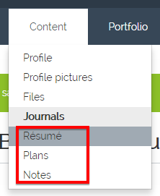

2.4 Creating a “page”
A Mahara “page” can be used as a targeted e-Portfolio. For example, you may want to create a page that showcases your accomplishments as a musical performer for prospective employers or clients. You might add a resume of qualifications and recent work, and supplement this with publicity pictures and testimonials from recent clients. You may even wish to add audio or video recordings of your performances to allow others to judge for themselves.

To create a page, hover over the “Portfolio” tab and click on “Pages”.

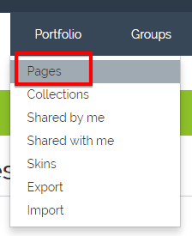

This will take you to a list of your current pages, which at this stage will probably only include you “Dashboard” and your “Profile page”. To start a new page, click on “Create new”.

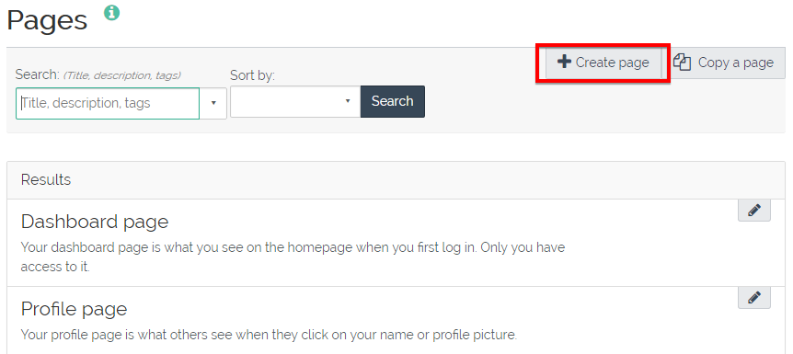

The process of adding content to your pages is the same as your public profile page; you have the options on the right-hand side to “Edit content”, “Edit layout” and “Choose skin”, with the added option to “Edit title and description”. When you are editing the content, you can choose from the list on the left-hand side.

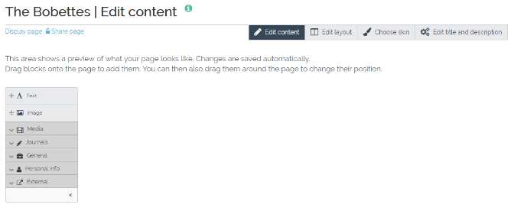

To add content to your page, select from the options in the left-hand menu and drag them into the columns, [See 1.2 Creating a PUBLIC Profile, above]. These can include text, images, audio files, external media, etc.

However, now that you have uploaded a range of files to Mahara, you have a few more options to consider. For example, you could add an “Image gallery” or a “Folder”, using the folders you organised your files into earlier.

2.4.1 Linking a Journal to your page
You also now have the option of linking your journal to your page. To do this, click on “Journals” in the left-hand menu, select one of the options and drag it to its position on the page. You can either add an entire journal, selected entries, new entries or entries with particular tags.

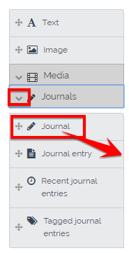

In the “Journal: Configure” box, you will need to add a Block title and select the journal or the specific entries you are adding. Even if you only have one journal or one entry, you will have to select it to ensure it appears.

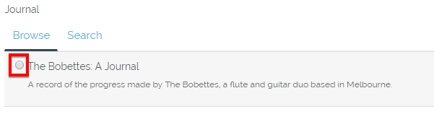

If you have chosen to add a whole journal, you will have the option of how many entries to include on the page at a time.

Don’t forget to click “Save” down the bottom of the box when you’re done. Your journal, and any attachments you have added to it, will now appear on your new page.

Once you have finished adding content to your page, click on “Display page” in the top left-hand corner to view the final product.

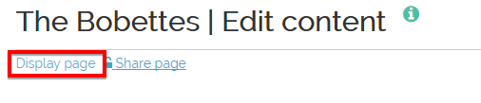

*****

3. Using your ePortfolio

3.1 Uploading your ePortfolio to Moodle for Assessment

Note for School of Music Students
Now that you have a Mahara profile and at least one page with a variety of files and a linked journal feed, you are ready to consider submitting your e-Portfolio contents to Moodle. This process is done entirely through the “Assessment” page of your unit’s Moodle site.

When you select your “Mahara assignment” option, you will find it automatically displays your name and the pages you have created. This integration of the Mahara and Moodle platforms makes submission very easy. Simply select the page/s you would like to submit for assessment, and click ‘Submit’.

3.2 Sharing your e-Portfolio
You can use your e-Portfolio to showcase your skills as a musician and as a dedicated worker to potential employees. To do so, hover over the “Portfolio” tab and click on “Shared by me”.

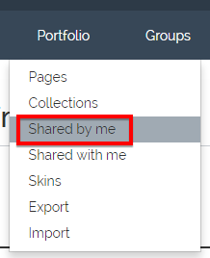

You will see a list of the pages you have created. Next to the one you would like to share, there are two icons.

Click on the ‘Edit Access’ (lock) icon, and change the access of the page to “Public”. Click “save” down the bottom of the page.

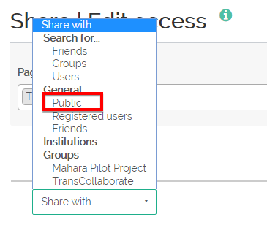

Click on the “Secret URLs” (globe) icon, then on “New Secret URL”.

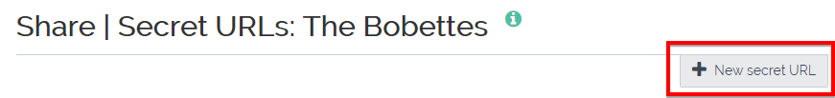

This will create a URL that you can use to share the page with anyone. Select the “Copy” icon, and paste it into the relevant email, document or website.





